**15 POINTS STP**

Points: Solve the following Spanning tree

|  |  |  |
| --- | --- | --- |
| Name | MAC | Priority |
| SW1 | 00:20:CD:35:DA:40 | 29866 |
| SW2 | 00:22:CD:35:DC:40 | 29866 |
| SW3 | 00:21:CE:45:DC:40 | 29865 |
| SW4 | 00:21:CF:00:DA:40 | 29865 |
| SW5 | 00:22:CF:35:DA:40 | 29866 |
| SW6 | 00:20:CF:35:DB:40 | 29865 |
| SW7 | 00:21:CF:35:DC:40 | 29865 |
| SW8 | 00:20:CE:35:DC:40 | 29861 |
| SW9 | 00:21:CE:35:DA:40 | 29865 |
| SW10 | 00:21:CE:25:DA:40 | 29875 |
| SW11 | 00:21:CE:35:CA:40 | 29865 |

(3) Root Bridge

(3) Root Ports

(3) Designated Ports

(3) Blocking Ports

(3) Forwarding Ports

Assume port numbers wherever  
necessary

|  |  |  |
| --- | --- | --- |
| SW12 | 00:21:CE:35:CA:40 | 29861 |
| SW13 | 00:21:CE:35:CA:40 | 29865 |
| SW14 | 00:21:CE:35:CA:40 | 29865 |
| SW15 | 00:21:CE:35:CA:40 | 29865 |

NOTE: STP costs in subsequent pages

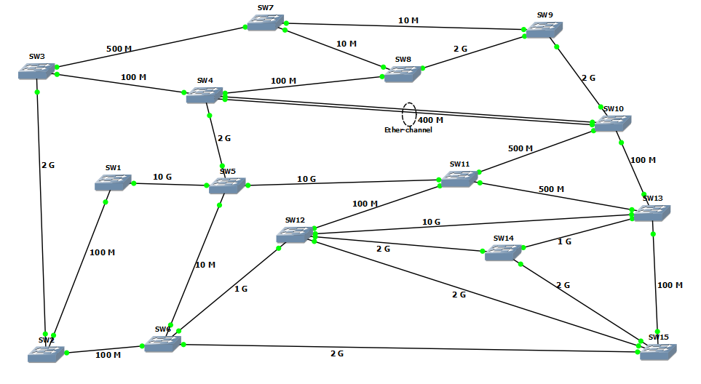

**Another 15 STP points!!**

Now S12 switch has been replaced by an older switch that has following MAC and priority

|  |  |  |
| --- | --- | --- |
| Name | MAC | Priority |
| SW1 | 00:20:CD:35:DA:40 | 29866 |
| SW2 | 00:22:CD:35:DC:40 | 29866 |
| SW3 | 00:21:CE:45:DC:40 | 29865 |
| SW4 | 00:21:CF:00:DA:40 | 29865 |
| SW5 | 00:22:CF:35:DA:40 | 29866 |
| SW6 | 00:20:CF:35:DB:40 | 29865 |
| SW7 | 00:21:CF:35:DC:40 | 29865 |
| SW8 | 00:20:CE:35:DC:40 | 29861 |
| SW9 | 00:21:CE:35:DA:40 | 29865 |
| SW10 | 00:21:CE:25:DA:40 | 29875 |
| SW11 | 00:21:CE:35:CA:40 | 29865 |

|  |  |  |
| --- | --- | --- |
| SW12 | 00:21:CE:35:CA:40 | 29861 |
| SW13 | 00:21:CE:35:CA:40 | 29865 |
| SW14 | 00:21:CE:35:CA:40 | 29865 |
| SW15 | 00:21:CE:35:CA:40 | 29865 |

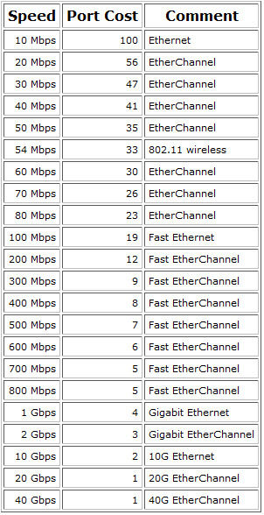



(25) Steven P. Jobs, the Apple Inc. chairman and co-founder who pioneered the personal-computer industry and changed the way people think about technology, died Wednesday at the age of 56. As a tribute to Mr. Jobs, Apple decided to set up a new personalized cloud network for the new Apple products being sold, but Apple received only a reserved block of IP addresses. Now, the network Engineers of University of Colorado at Boulder were asked to optimize the address allocation. The network received by Apple was 100.101.102.103/14 and VLSM was required for reserving the cloud subnet for the following new Apple devices:

iPad 2: 7 networks of 8189 users each

iPhone 4S: 4 networks of 16380 users each

Along with these, Apple also decided to set up Cloud network for Mac Books and iMac PCs running the new Mac OS X Lion, but being sold at cheaper rates. It was subnetted with the following requirement:

MacBook Air: 4 networks of 2048 users each

MacBook Pro: 2 networks of 16383 users each

iMac: 5 networks of 2000 users each

Apple TV has following 5 reserved blocks:

100.102.32.0/19

100.101.224.0/20

100.103.64.0/19

100.100.176.0/21

100.101.208.0/20

Also, the company reserves two blocks of 100.100.32.0/19 and 100.102.64.0/19

for the Apple Employees and Apple resellers.

Design the subnetting in an efficient manner. Engineers are allowed to use Pie Diagram for their convenience.